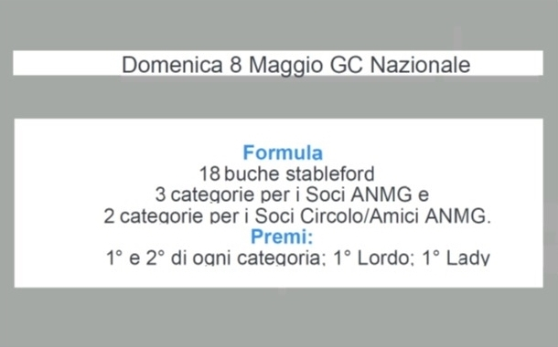

**CLASSIFICA SOCI ED AMICI**

|  |  |  |  |  |  |  |  |  |  |  |  |  |  |  |  |  |  |  |  |  |  |  |  |  |  |  |  |  |  |  |  |  |  |  |  |  |  |  |  |  |  |  |  |  |  |  |  |  |  |
| --- | --- | --- | --- | --- | --- | --- | --- | --- | --- | --- | --- | --- | --- | --- | --- | --- | --- | --- | --- | --- | --- | --- | --- | --- | --- | --- | --- | --- | --- | --- | --- | --- | --- | --- | --- | --- | --- | --- | --- | --- | --- | --- | --- | --- | --- | --- | --- | --- | --- |
| |  |  |  |  | | --- | --- | --- | --- | |  | | | | | **1° CATEGORIA** | | | | | 1° Lordo | UNGARI FABIO | NAZIONALE | 26 | | 1° Netto | PARK ITAE | TERRE CONSOLI | 33 | | 2° Netto | IMPARATO MARCO | NAZIONALE | 33 | |  | | | | | **2° CATEGORIA** | | | | | 1° Netto | DELLA CAMERA MAURIZIO | NAZIONALE | 34 | | 2° Netto | CAPRIOLO SIMONA | NAZIONALE | 33 | |  | | | | |  | | | | | 1° Ladies | SCARVAGLIERI FIORELLA | NAZIONALE | 28 | |  |